**JAVA BASICS**

**\*\*\*\*\*\*\*\*\*\*\***

* Popular Code editors
* **Anatomy of a JAVA Program**  
   * Function = smallest building block

= a block of code that performs a task (i.e. button on a tv remote, have a function to send email to somebody or validating users input )

* + **Coding a function in Java**  
    specify the return type of the function

Some functions have a return type of a value of a number, a date or nothing (void)  
After the return type we have the name of our function followed by a parenthesis. The name should have a proper descriptive name that clearly identifies the purpose of this function. Note that the name starts with a small letter.

In this parenthesis we would add the parameters of this function. Parameters are used to pass values to our function.

After the parenthesis we will have curly braces and which we will have the actual JAVA code. The first curly brace will be on the line where we define our function.

Every JAVA program should at least have one function and that function is called the **main function.**

**EXAMPLE OF A FUNCTION**

void main ( ) {

….

}

**Main** is the **entry point** to our programs therefore whenever we execute a Java program the main function gets called andthe code inside this function gets executed.

Function cannot exist on their own and therefore need to belong within a CLASS  
CLASS = A container for one or more related functions  
Classes are used to organise our code, think of how items are organised at a supermarket ……each section has related products  
  
Each program should at least have one class that contains the main function and within this main class we can have **functions**

**EXAMPLE**class Main {

void main ( ) {

…..

}

}

We refer to the functions within the main class as methods  
Therefore a method is a function that is part of a class  
When outside of the class it is called a function  
  
In JAVA all these classes and methods should have an **access modifier**  
An access modifier is a special keyword that determines if other classes and methods in this program can access the classes and methods  
Examples of Access Modifiers are Public(accessible from other parts of the program) or Private  
Access Modifiers are put in front of our class and method  
NOTE: The main method of the program should always be STATIC  
  
**EXAMPLE**   
  
public class Main {

public void main ( ) {

…….

}  
}

This is the basic structure of a JAVA program

To name classes we use the **P**ascal**C**ase meaning  
 the first letter of every word should be upper case  
 To name methods we the **c**amel**C**ase  
  
Example 2(NB!!! Read the comments on this screenshot)  
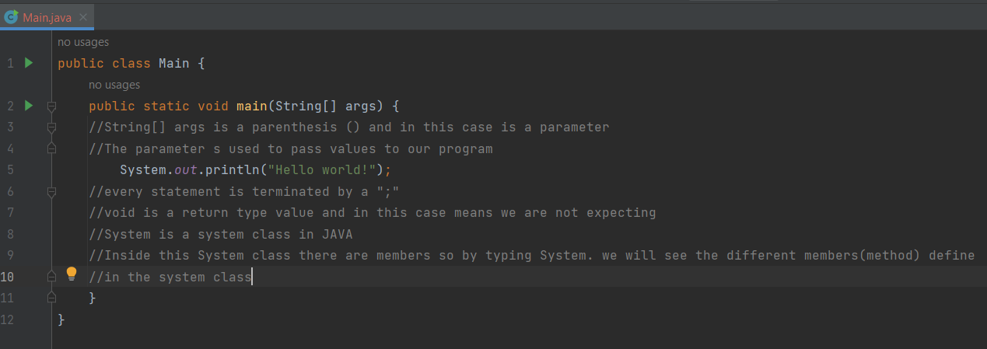

**VARIABLES**

We use variables to temporarily store data in the computer’s memory   
We always initialise our variables before storing them  
Using a comma we can declare multiple variables on the same line but this is dirty coding (Fig 1) so it is better to declare one variable in each line (Fig 2)  
Note that int is he type of variable,  
age = name/label or formally called an identifier  
‘=” = assignment operator  
we are declaring the variable  
  
FIG1  
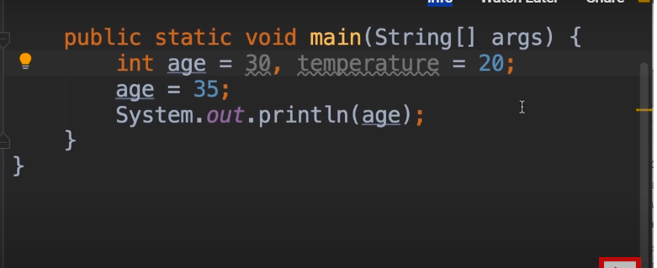   
  
FIG 2

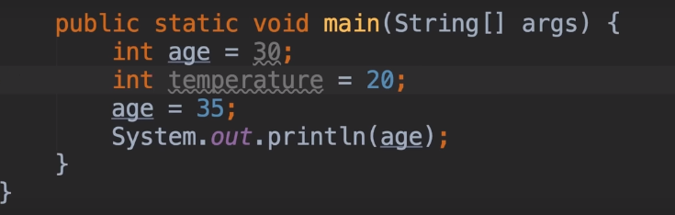

We declare a variable as with the above example where  
**Int** (integer) is a **type** of variable(whole numbers), age is the **identifier (name or label)** and the equal sign is **assignment variable**In the above example we are **initialising** the variable  
Also remember that we need a ”;” at the end of each statement

We use camel casing when naming in our methods. See example   
Fig3  
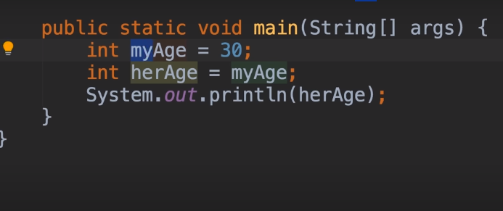

**Types in JAVA**

Here are two DATA types in JAVA mainly Primitive and Reference Types  
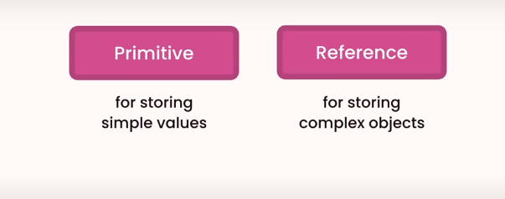

PRIMITIVE Types  
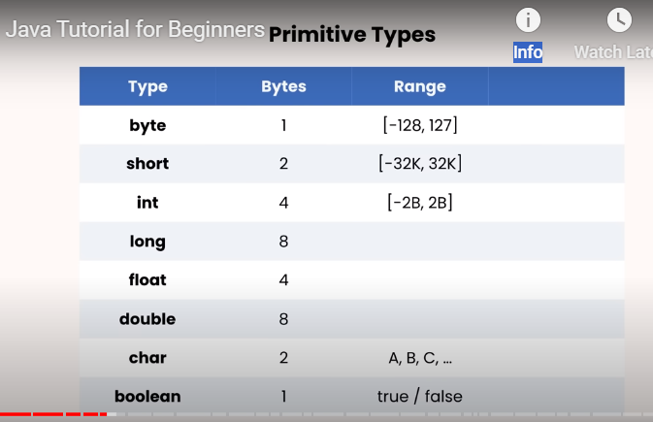  
  
**Byte,short,int,long** = these are for storing whole numbers with no decimal points  
**Float and double** are for storing numbers with decimal points  
  
So from previous example we realise that to store someone’s age we do not need the **Int** type as that is used to store as big as 2 billion whereas we can use byte which can store up to the **numbers 128.**Instead we can use **int** to store the number of times a youtube video has been viewed  
Good practice when naming variables is to use meaningful names i.e int viewsCount  
In JAVA we can use an underscore to separate numbers like how we would use commas in

**NOTE:**  
When declaring a variable that is **long,** the compiler will see this as still an Integer so we need to put an “L” as the suffix of the defined number. Dame occurs with a **float** we need to add an F at the end. See below example  
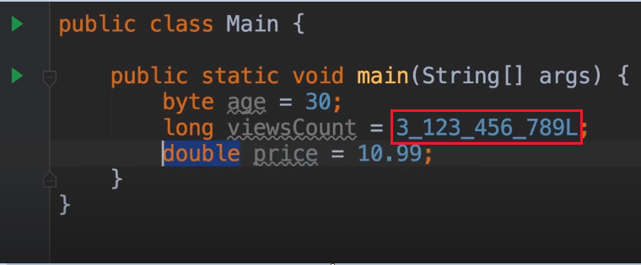

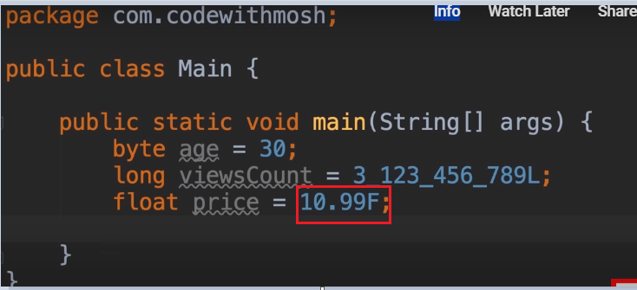Also note that when we define a **char field** we nee to use **single quotes** unlike string which uses double quotes  
  
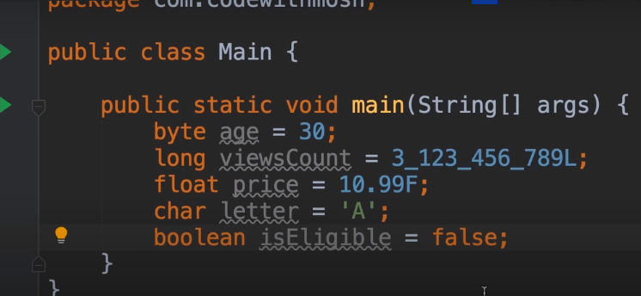  
Note that the word false for Boolean is a **reserved key word** as it is in orange so we cannot use it as a variable name

**REFERENCE TYPES**

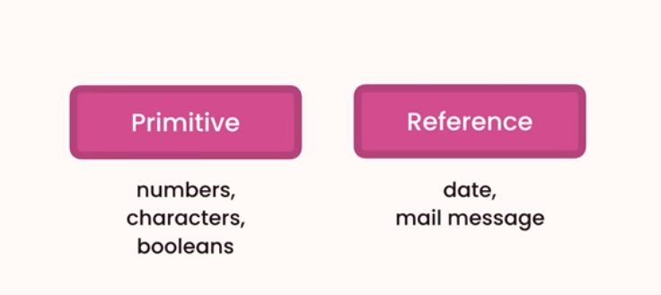  
  
Primitive = we store simple values like number, single characters and Boolean values.  
Refernce = store more complex objects  
NOTE: An object is an instance of a an instance of a Java class, meaning it is a copy of a specific class. Java objects have three primary characteristics: identity, state, and behavior  
When we use the date class, Intellij automatically imports the date package, see below  
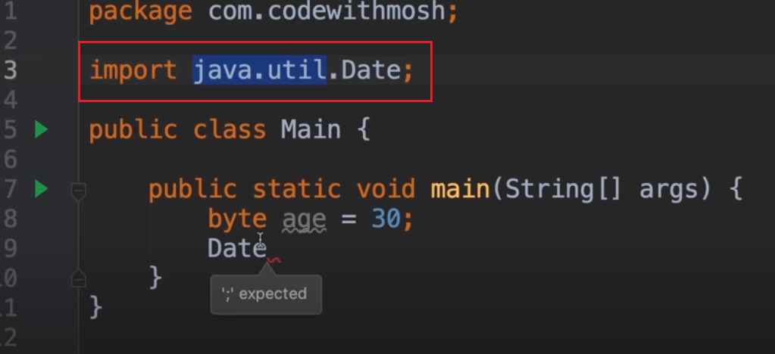  
Note: above line 8 is the age variable  
Note:  
We are import the date class that is in the java,util package  
When dealing with Reference Types we need to use the **new** operator **allocate memory** unlike when dealing with primitive types  
Difference between primitive type and reference is that with primitive type we do not need to allocate e memory as allocated and released by Java Runtime Environment as with reference we have to allocate memory

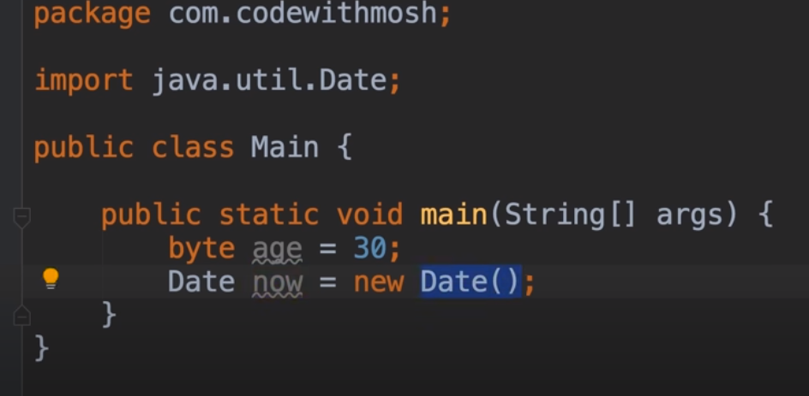  
In the above example we can see that when defining the refence type we need to say Date variable type = NEW Date()  
The variable defined here is an instance of the Date class  
  
**Note:** the short cut for System.out.println is SOUT then press TAB  
  
Since we want the value of our date object we do not put “ “ around now  
  
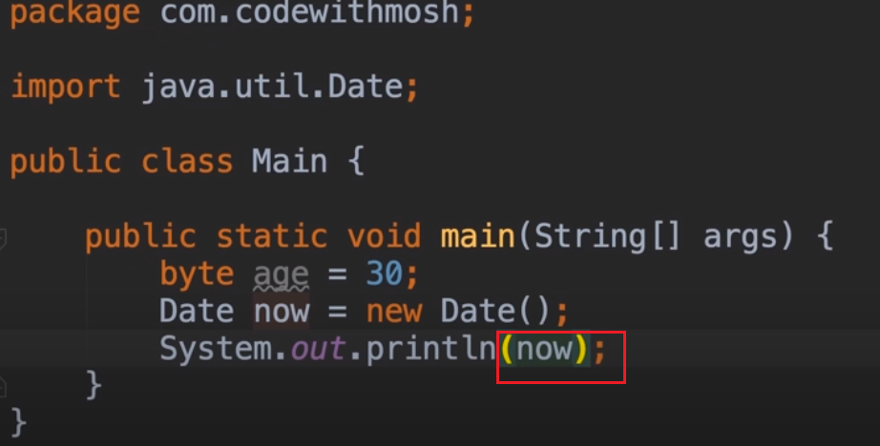  
  
**Primitive type vs Reference Types(revisit this)**One difference between primitive and reference data types is the way that we declare and initiliase the The other difference between the two types is memory management  
With primitive the values of x and y are at two **different memory locations** so they are completely independent of each other. If the value of X is changed then the value of Y is not affected

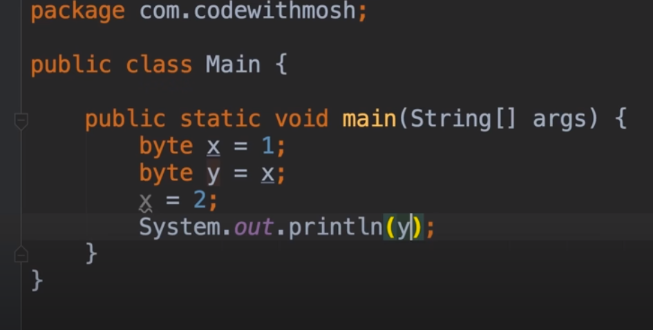  
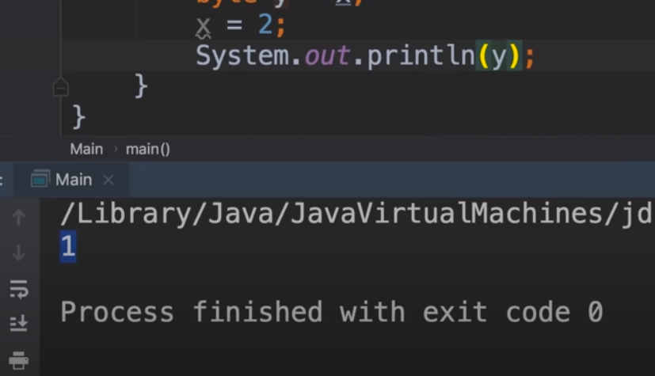  
  
The following is an example of Reference type where we are using reference type of point or point object. Notice the import

With Reference Type we always use “new”  
  
Note: Point1 and Point2 reference the same address and that address i.e 100 is stored upon initialisation 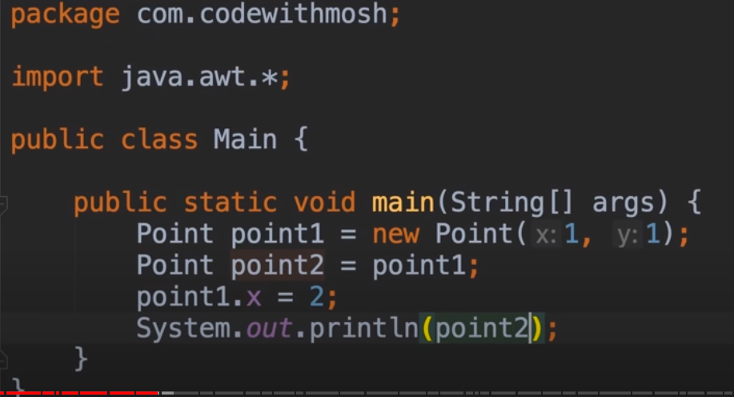 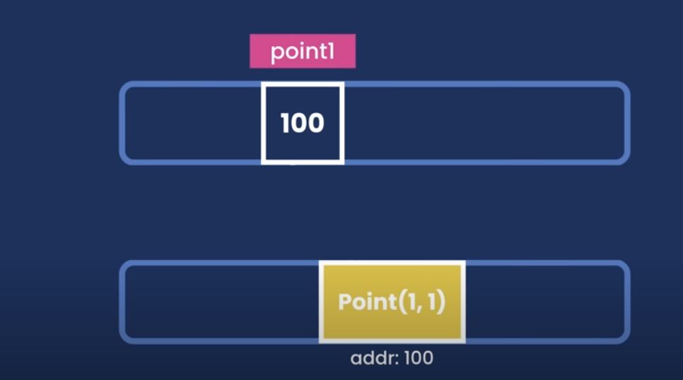  
The reference types store the reference to the object and not the value and so the two objects are not independent of each other  
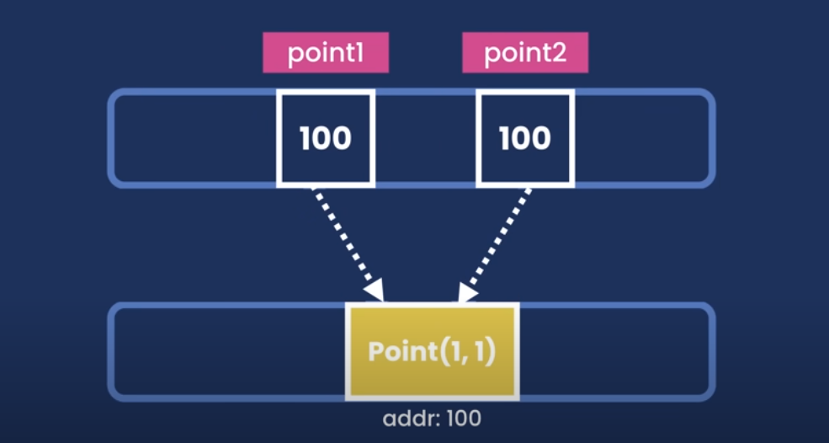  
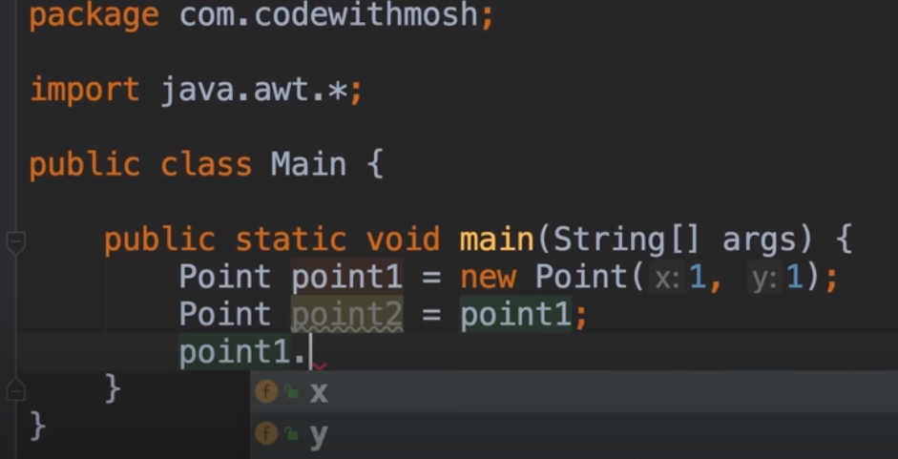  
  
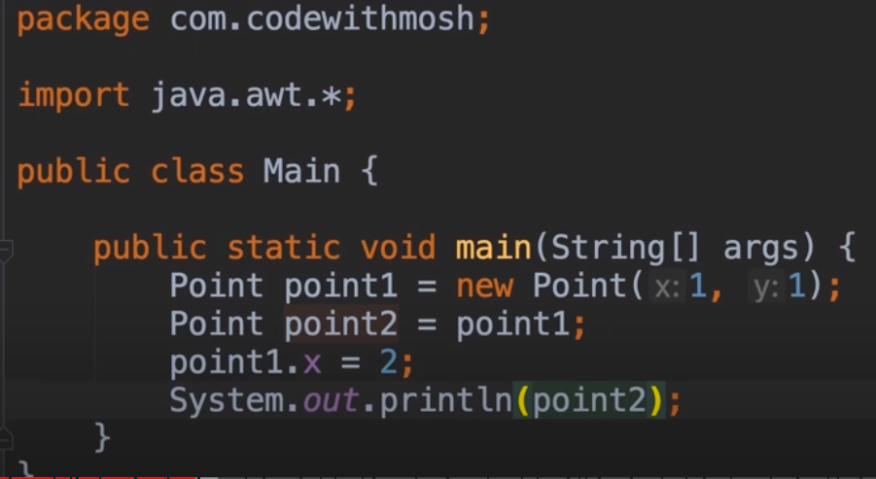  
  
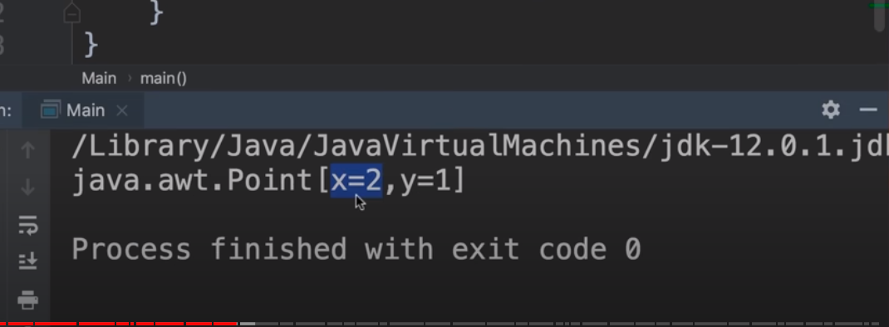  
  
**STRINGS**

* Earlier on we printed the “Hello World” message on the terminal. This is called a string, more accurately a **string literal (string value)**
* Instead ofprinting out the string directly using SOUT we can define a variable for this string as a message, using reference type and the string class  
  Remember that reference types always have the new operator (see below)  
  The String class does not have an imported package like other reference types because the package is automatically imported. This is because of the java.lang package
* For String class we **do not have** to instantiate the variable using the new operator because we get a warning  
  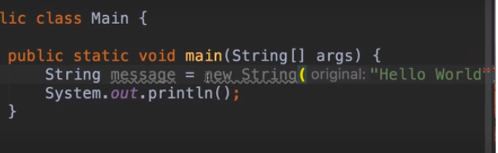  
  So instead we set it to the string literal like this  
  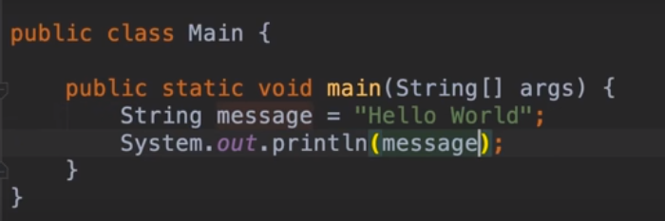   
  When looking at it it looks like we are using a primitive type but this is just a short hand to **initialise a string variable  
  Remember that () are called parenthesis**
* Strings can be concatenated with a “+” operator see below example  
  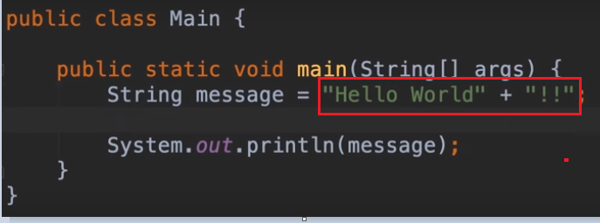
* Since string is a class it has members that we access using the “.” operator.   
  See below   
  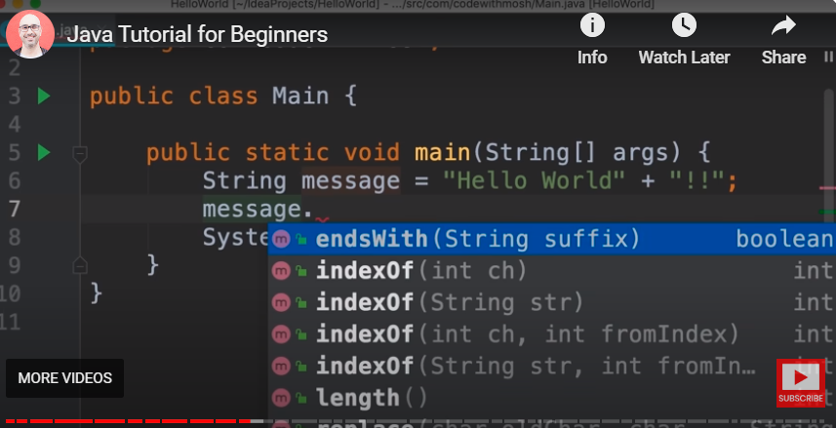  
  **The above are all the methods/functions defined in the string class**The above highlighted member would check if the string suffix endswith….see below example  
  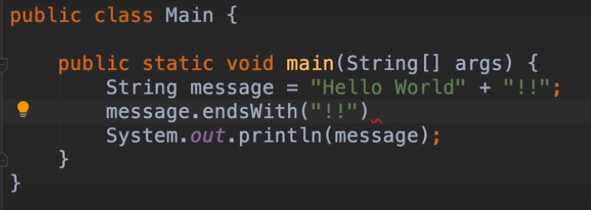Instead of printing the message, we can print the expression  
  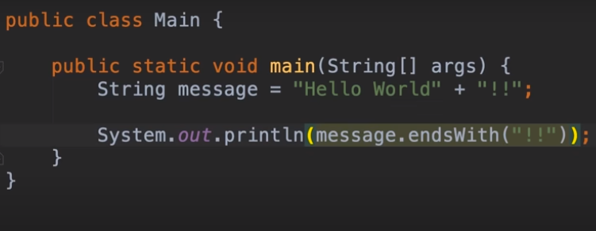  
  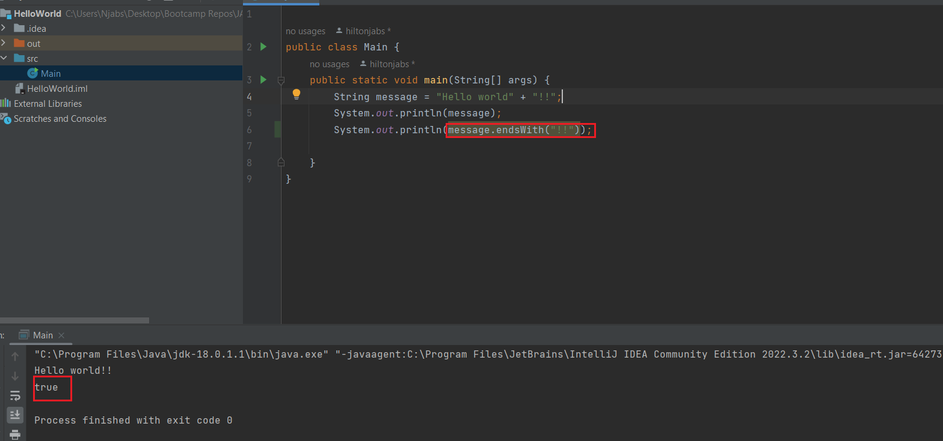
* Another useful method is .length which will tell you how long the length of the string is and .startsWith   
  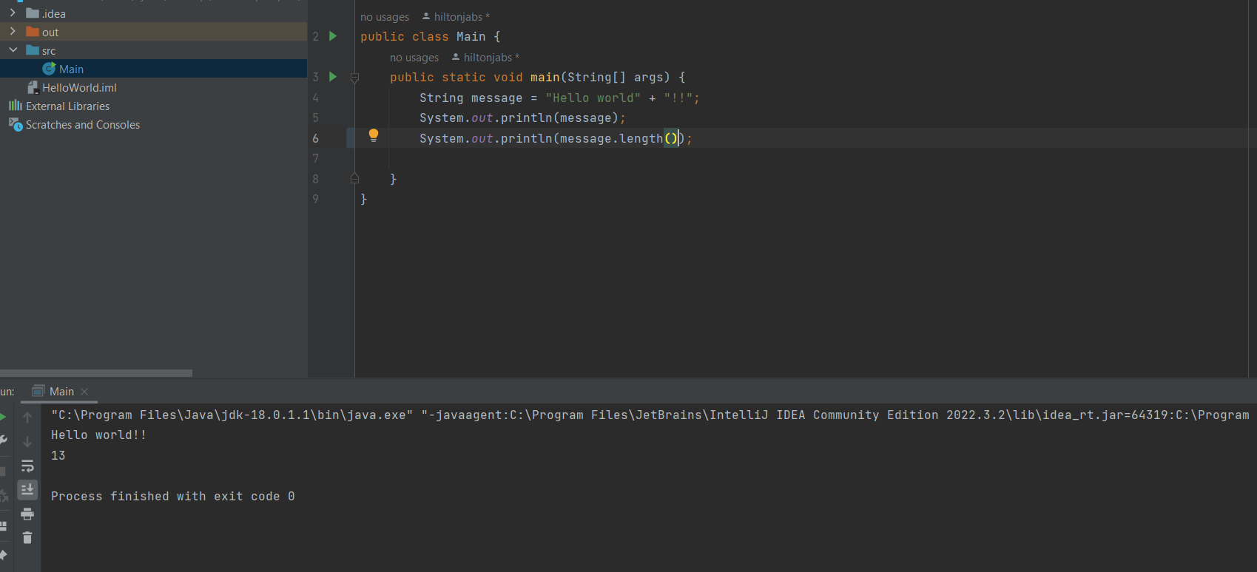
* The methods are quite useful because with the length method we can check the length of the username for example and if the length is greater than a certain number we can return an error
* Another useful method for the string class is .indexOf  
  This returns the index of the first occurrence of a character in a string so for example below the first occurrence of the letter “H” is 0(zero) or if we pass “e” the index of e is 1 and “o” would be 4
* **NOTE**: If the string is not there then it will return -1
* Another example of a string method is .replace and with this we can replace one or more characters  
  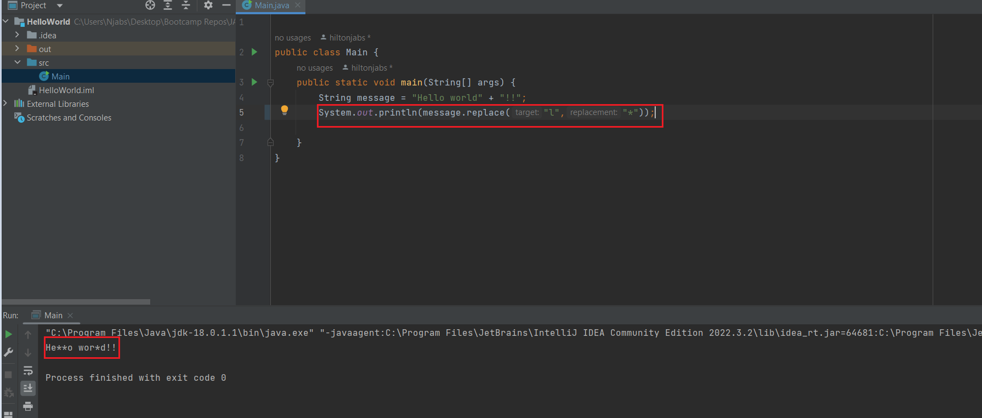
* **NOTE:**

In the above example target and replacement are called **parameters**  
“l” and “*” are values but in programming terms these values are called **arguments**

* **The above method does not modify our old string but returns a new string**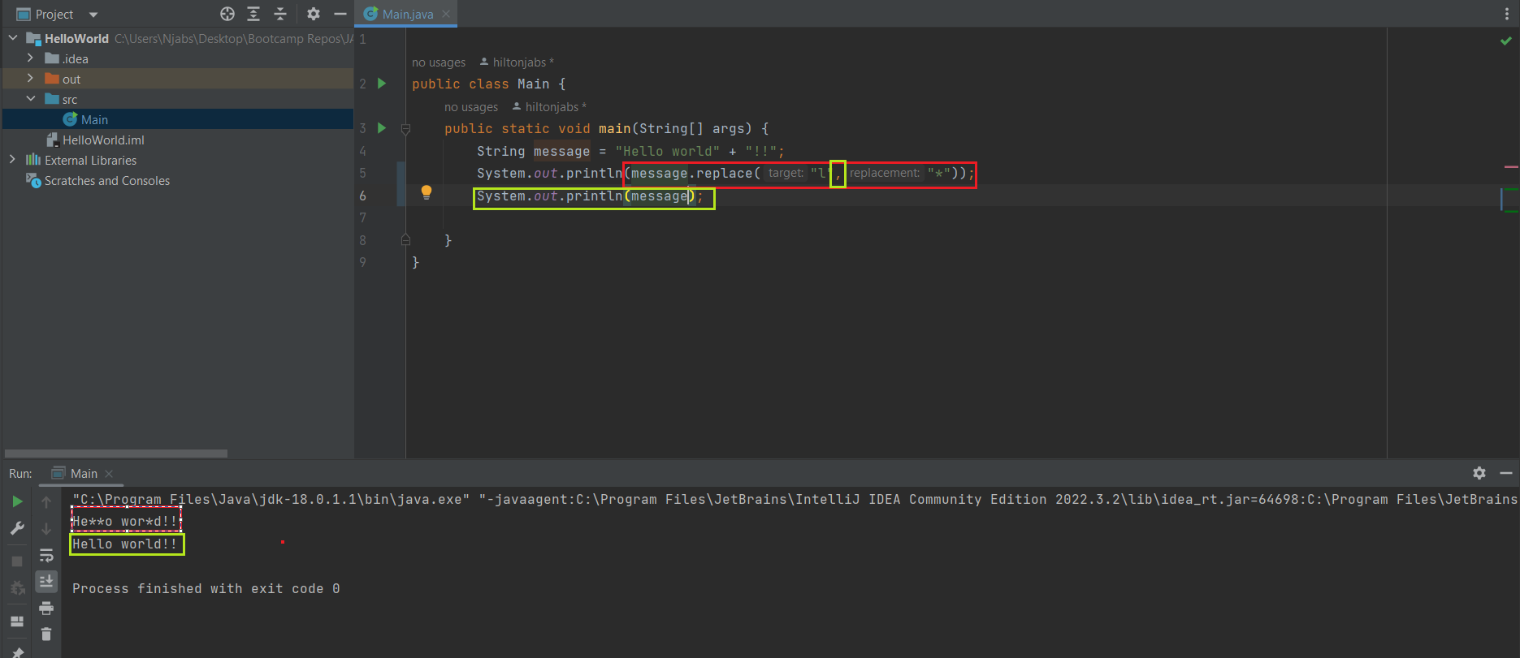
* Another useful method is .toLowerCase and toUpperCase  
  Also .trim is useful for trimming out white spaces before and after. See below difference between original with white spaces and ours where we trim the white spaces 